10.95: a) The initial angular momentum with respect to the pivot is 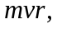and the final total moment of inertia is 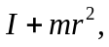 so the final angular velocity is 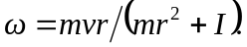
b) The kinetic energy after the collision is
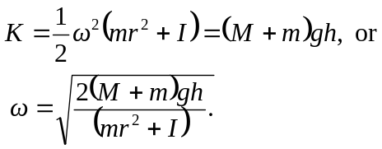

c) Substitution of 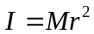into either of the result of part (a) gives 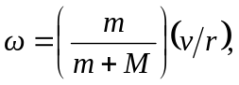
and into the result of part (b), 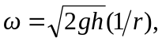which are consistent with the forms for v.

